The Costs and Benefits of UK Value Mapping
A paper by Tony Vickers
This paper forms part of PhD studies at Kingston University School of Surveying. It takes the Action Plan Logic Diagram (Figure 1 in Vickers 2005) from an analysis of the final stage of a Policy Delphi on the subject and tries to place indicative figures (in millions of pounds sterling) on both the costs and benefits of each item in that Plan, in the logical order that individual actions would need to occur. It also estimates the time required for each action to be completed (and/or before it can be followed by other actions in the Plan). Actions that the Logic Diagram shows need not be complete in order for Value Mapping to happen are not included.
From this exercise an overall costed programme, with indicative dates for commencement and completion of each component, is arrived at. The costs are specified firstly for Government and then for ‘UK plc’, i.e. all sectors of UK society. The programme takes two alternative forms: first ‘market led’, assuming that no political support for land value taxation (LVT) is given by Government; second ‘tax reform led’, based on the assumption that Government will give a minimum level of support to LVT at each stage until trials of its effectiveness as an economic policy tool are proven (again assuming this to be so) – partly helped by use of value maps. However no account is taken of the value to the economy or society of LVT, which is assumed to be neutral for this purpose although that is probably the least likely outcome of a major implementation of LVT.
Value Mapping resulting from just the market-led route will not be as fine-grained as if it is tax-reform-led. It will probably not be at land parcel level but limited to some aggregated geography, such as postcode, census output area or even larger. This is illustrated with sample value maps at scales that increase with time and expenditure in Figure 1, the applications possible towards the top of the diagram being much more limited but still useful to spatial planners and others.
The table below does not include Actions that only need to precede a decision on LVT. However it is regarded so highly desirable that some property tax reform (short of LVT) is carried out (Action 6 will confirm this or not) that the two most expensive Actions on the tax-reform-led route are included: completion of land registries and re-engineering of property tax IT systems for CAMA/GIS. These then link, by dotted line on Figure 1 (amended below from the version in the Delphi Round 3 analysis), to the final box: UK Value Mapping. An implementation of Value Mapping at the most fine-grained level could therefore technically be implemented without LVT and all associated costs of such an outcome are covered here, as far as is possible at this stage.
Action |  | Logic / [yrs]  Notes | Costs |  | Benefits
No. | Description | Logic / [yrs]  Notes | £m | Rationale | £m | Rationale
1 | Government support for idea of national land valuation | Original action, essential at some stage if Value Mapping is to occur.  Should only take a month from first consideration to announcement.  [0.1] | Min. | Although many commentators would link this to a move towards LVT, it is quite possible to argue that it is a requirement of good governance to have an understanding, in general terms, of how local economies are faring; also to be able to justify public expenditure on the basis of its land value effects.  The only cost (other than political risk) would be that incurred in preparing a Cabinet paper. | 2.5 | By signalling that it intends to carry out a national land valuation, Government would lever in private sector and charitable think-tank resources to help devise detailed means of achieving this aim. There are clear benefits to the property, insurance and investment communities in having definitive up-to-date value mapping.
7 | Appoint Government Champion for GI | Probably necessary to secure Actions 2, 6 and possibly 9.  [0.1] | Min. | Can be part of an existing portfolio and budget to come from that supporting newly formed GI Panel. At most, part of a Grade 7 post with share of secretarial support. | N/A | Not specific to Value Maps, needed in any case. Given size of GI industry and role of publicly funded agencies in it, must be scope for significant savings arising from work of GI Panel generally.
2 | Government support continuous monitoring of key datasets. | The word ‘all’ is removed to bring this into line with consensus that this is ‘a good thing’ but each dataset needs to be looked at on its merits.  This probably needs to precede Actions 13, 10. [0.1] | Min. | Of itself, expression of an aspiration costs nothing and should stimulate detailed studies on various relevant datasets, in particular property and land rents/prices/values. | N/A | Unless synergies are identified by the GI Panel or industry groups, each case needs to be justified on internal savings. In some cases (inc. property values), costs of monitoring are already being incurred but the benefits are not being realised because of failure to recognise external uses of the data.
13 | Revive National Land Use Database concept | Probably requires Actions 1 & 2 to occur first. Must precede decision on whether to do UK Value Mapping.  [1.0] | 2+ | Assuming Planning Portal exists, much of the infrastructure would be in place for NLUD. Remaining costs have probably already been identified. Data collection on actual use quite easy to collect, at local level. | N/A | Likely to be required in due course (by 2009?) by INSPIRE. Also widely seen as ‘good’ in its own right. Main tangible benefits will fall out of Action 6
6 | Value Maps Market Analysis | Essential that Action 1 has occurred first. Very desirable for Action 7 to precede it – or happen before work is complete, because decision on UK Value Mapping follows straight on.  [1.0] | 0.3 | Desk study only, ideally by management consultants with experience of property industry and information business process engineering. Could involve secondees from key agencies (VOA, HMLR) but otherwise largely privately funded. Not unlike NLIS study 96/7. | 1-5++ | Even at ‘small scales’, crude value mapping likely to show potential positive returns on cost of study. More detailed maps likely to yield much larger positive benefits – but at greater expense and requiring tax reform. So scope must include all options and (if not already done) Actions 8, 11, 12, ( perhaps also 10, 14)
 | TOTALS | ‘MARKET-LED’ | 2.3 |  | 5-10
8a | Authorise retrospective completion of Land Registers | If unit of land being valued is based on indiv. titles, essential. Otherwise only essential for LVT.  Need to table Secondary Legislation in Parliament and possibly consult stakeholders – 6 months max.  [0.1] | Min. | Chief Land Registrar has said he plans to do this for E&W anyway, within existing resources, by about 2014. Only if Government wants more rapid completion will it cost more. However it might require priorities for initial title registration to be changed, to produce certain areas that are complete (for value mapping or other trials) before others. A study of likely costs and benefits needs to be done before this decision is made. | 2+ | By allowing enquiries affecting unregistered land to be wound up earlier, some internal savings for HMLR and other Registries should be possible.  This assumes that the costs of first registrations are all borne by the title holders, not by taxpayers in general. The saving here comes mainly from being able to stop offering financial inducements to voluntarily register title (a loss of revenue).
8b | Completion of Land Registers | Needs to be complete for areas that are subject to LVT, before valuations are completed and LVT levied.  [9.0 – but for nation-wide LVT could be completed sooner at greater cost] | ?10+ | Assumes that completion is planned and budgeted for already. This is just the extra cost of devising systems to prioritise workload differently and to close down the non-registered land processes earlier. The costs would mainly fall at the start and end of the period between Action 8a and about 2014 (when completion is already anticipated). | 20+ | There must be significant internal benefits for Registries when they no longer have to deal with enquiries relating to unregistered land. These would be expected to outweigh costs, after a few years. Savings will be permanent and will also benefit users, directly (in cash terms) and indirectly (service quality and new services). There should be significant extra revenue from by-products of Registry systems, such as legal land parcel datasets, Some of these will become apparent only when Value Mapping exists.
12a | Government support to LVT desk studies | Needed to unlock relevant datasets, as shown by OxonLVT Trial. Also must occur before Action 6.  [0.1] | Nil | Some political risk but no actual direct cost implications, other than staff time within public sector agencies that hold the data. Presumes that each agency would need to cost-justify their own work but partnerships with academia and think-tanks become more likely. | Nil | No immediate cash benefit but Government’s policy stance on a range of key issues becomes more defensible, e.g. it can say it has taken up recommendations made recently by several studies (Rogers 1999, Evans & Bate 2000, Jacobs 2000, Barker 2004)
11 | Re-engineer property tax IT systems for GIS/CAMA | Probably triggered by 12a, further encouraged by 12c/d but unlikely to be fully actioned unless LVT decision and/or Value Mapping decision is positive. Likely to be time-critical and most expensive single activity overall.  [5.0] | 200+ | Assumes GIS/CAMA already used for current CT/NDR systems by 2007, with no further development until after then. Feasibility study alone could cost £2-5m and could run parallel with Action 12c (LVT trials) and Action 6 (Value Maps Market Analysis). Overseas experience indicates that land value ‘drops out’ of consistent CAMA/GIS-based property tax assessments, so no decision needed on nation-wide LVT before system is designed and validated. | 300+ | Assumes that LVT (or at least US-style ‘split-rate’) replaces current property taxes and doesn’t run alongside it for more than 5 years. This is the expected internal saving over a revaluation cycle (10 years) from having rolling revaluations and fewer appeals.
 | TOTALS | TAX-REFORM-LED | 210+ |  | 322+
 | MAX | (Market-led + tax-reform-led) | 213+ |  | 332+

Figure 1: Action Plan Logic Diagram (updated)
Action 1: Government support for idea of national land valuation
Action 2: Government support continuous monitoring of key datasets
Action 3: GI Panel reporting to different Department than OS
Action 5: PPP Agreement to produce national land value dataset
Action 6: Value Maps Market Analysis
Action 7: Appoint Government Champion for GI
Action 8a: Authorise retrospective completion of Land Registers
Action 9: Separate data custodianship responsibilities from production and use.
Action 10: Create network of Local Land Information Managers
Action 11: Re-engineer property tax IT systems for GIS/CAMA
Action 12c: Government support tax-raising trials of LVT
Action 13: Revive National Land Use Database concept
Action 14: Extend property taxes to all urban land
Action 8b: Completion of Land Registers
Action 12a: Government support to LVT desk studies
Action 12b: Local authorities campaign for tax-raising LVT trials
Action 12d: Assess effectiveness of LVT for nation-wide taxation
Value mapping decision
LVT decision
NO
GO
UK Value Mapping
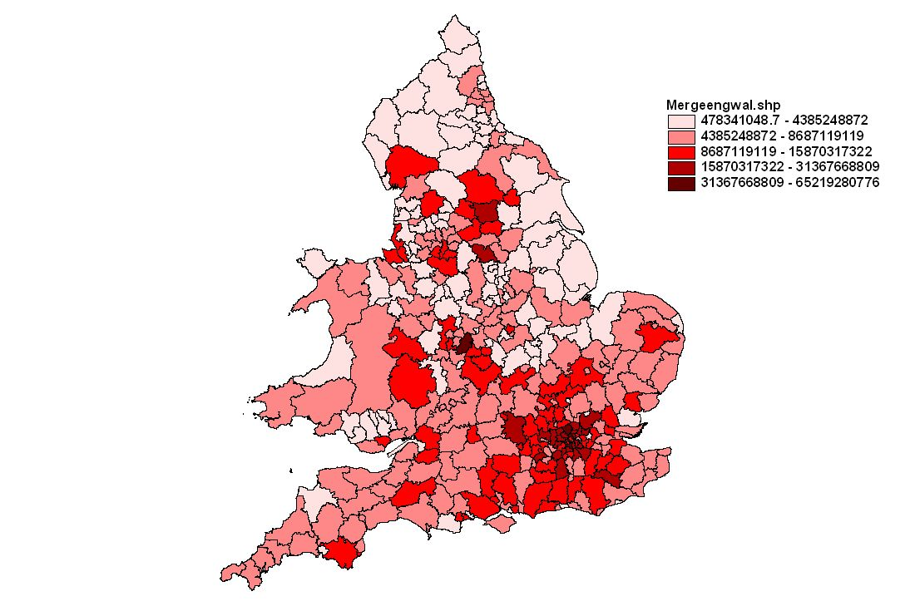
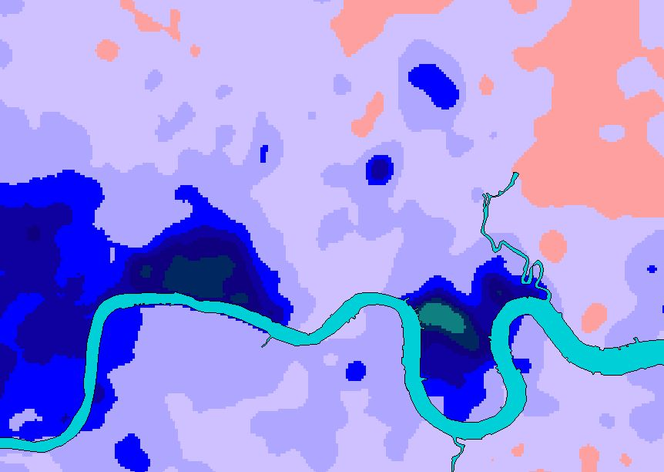
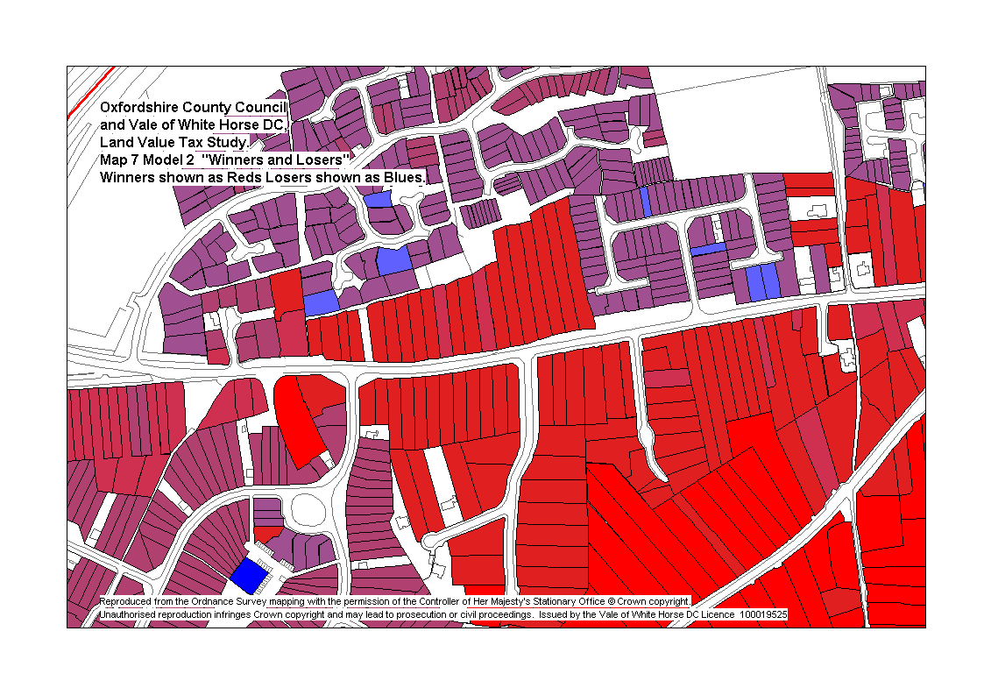

Comments on these Actions are as follows: Action 3 (GI Panel reporting to different Department than OS): seen as desirable, likely to encourage Actions 2, 7 & 9 – but not essential for this purpose. Action 9 (Separate data custodianship responsibilities from production and use): not relevant to value mapping, although possibly desirable for its own sake. Action 10 (Create network of Local Land Information Managers): naturally follows from Action 2 and might also be aided by Action 9; with Action 13 would facilitate Action 14. Action 14 (Extend property taxes to all urban land): a far less likely precursor to Value Mapping than LVT. Action 5 (PPP Agreement to produce national land value dataset): less desirable than having Government simply fund Value Maps directly, with cost recovery from commercial sales.

