LANDVALUESCAPE NEWS: issue 5 (December 2004)

“Monitoring the economic landscape”
Editorial: UK geographic information (GI) strategy and policy thinking – or rather lack of it – have dominated the latter part of my year. The Government recently announced it would shortly establish a GI Panel to provide ‘separate’ and ‘complementary’ advice on GI matters to that which the Director General of Ordnance Survey (DG OS) provides. Although the Association for Geographic Information (AGI) was set up 15 years ago to do just that (among other things), AGI wasn’t at first formally invited to nominate a single member of the Panel.
In the month prior to this announcement, two other GI-related events occurred: the publication of final reports of the Acacia Programme, which looked at the future of Addressing systems; and the launch of the main phase of Project Valuebill, which enhances the exchange and maintenance of property tax information.
Because property addressing, valuation and GI policy are at the heart of my PhD, I volunteered to lead the AGI’s responses to all three events. Something disturbing seems to be happening: the commercial interests of public agencies are being conflated with the wider interests of ‘UK plc’ and this is obstructing the progress of key pieces of ‘knowledge economy’ infrastructure.
OS is a powerful monopoly in a small but key industry. Few players in the GI community dare to take it on. We all expect property tax reform to be a highly charged issue, but many would be surprised at the poison eating away at ‘e-Government’ largely due to the workings of another Treasury ‘big idea’: the Trading Fund. So before addressing value maps, I’m addressing addressing!
Tony Vickers tonyvickers@phonecoop.coop
Visualising Landvaluescape: Developing the Concept for Britain.
My three parallel strands of PhD work are:
- A Policy Delphi Process involving stakeholder representatives and others interested in UK Value Mapping;
- Demonstrating a Value Map of an area of Oxfordshire, to test reaction to the concept; and
- Fact-finding through visits, the internet, e-mail and correspondence.
Strand 1 - The Policy Delphi
Rather to my surprise, after studying the responses to ‘Round Two’ from my virtual committee, it now seems best to de-couple value mapping from property tax reform and also to focus more on the place of land values in the national GI infrastructure. Overwhelmingly the issues are not technical but institutional. So the Policy Action Plan that I am now starting to put figures to (costs and benefits) has much less to do with tax than with GI policy.
This is the draft to which I am now starting to apply indicative costs and benefits:-
Table 1: UK Value Mapping draft Policy Action Plan
No. | Action
1 | Government statement of support for the idea of a national land valuation, independent of tax reform and primarily as a potential tool of land policy.
2 | Government to accept publicly that, in principle, the monitoring of all key datasets should be continuous and not periodic.
3 | Government’s proposed “GI Panel” to report to a different Department than OS (preferably Cabinet Office).
4 | Private sector consortium offer to Government to fund national land valuation.
5 | Public Private Partnership Agreement to produce and maintain consistent all-embracing land value dataset.
6 | Commissioning a UK Value Maps Market Analysis
7 | Appointing a Government Champion for GI, including Value Maps.
8 | Completing the UK Land Registers (map based).
9 | Separate data custodianship responsibilities from production and use, creating a State Enterprise Centre of Registers (SECR).
10 | Create network of Local Land Information Managers (LLIMs)
11 | Re-engineer property tax IT systems to fully exploit GIS / CAMA.
12 | Allow tax-raising trials of LVT
13 | Revive National Land Use Database (NLUD) according to its original purpose.
14 | Extend property taxes to all urban land
The reasoning behind this Plan can be found in my Round Two Delphi analysis at … http://www.landvaluescape.org/archives/RdTwoAnal.pdf (in Acrobat format)
and anyone can have a go at my Round Three (final) questionnaire, available from… http://www.landvaluescape.org/archives/Rd3Q.doc - a Word document to fill and return by email attachment to tonyvickers@phonecoop.coop . Participants are asked to consider the relevance, desirability and feasibility of each of the above Actions, also any links between them. They are then asked to rate in order a list of ten ‘stakeholder groups’ that could be either beneficiaries or enablers of value mapping in the UK, or both.
The deadline is 20 December for responses. In addition to the 23 people who participated in Rounds One and Two, the six who dropped out after Round One have been invited to re-join the process. They include the Delphi Group’s one member of the insurance industry, which I now see as possibly key to the future of value mapping, along with mortgage lenders and property investors.
I am continuing to hold one-to-one meetings with key members of my Delphi Group and with certain others who might be key enablers or beneficiaries. Many are, like me, members of the AGI (www.agi.org.uk), whose governing Council I’ve just been elected to.
I wrote a policy paper for AGI in the summer, calling for English and Welsh local authorities to be allowed to offset their up-front initial costs of improving their property tax data exchange with the Valuation Office Agency (VOA) in order to secure the fastest possible completion of the national land and property gazetteer (NLPG). VOA have adopted the geo-code that comes with NLPG as a new field in their databases, thereby allowing them to use GIS internally and in any future derived products such as value maps (see http://www.voa.gov.uk/news/press04/ct-england-modelling-tech.htm). The Government Department sponsoring local government has made Project Valuebill, the mechanism for improving property tax data exchange and maintenance, one of 22 local eGov National Projects (see http://www.localegovnp.org).
To my surprise, those in AGI who are thought to know most about UK addressing opposed my idea, claiming my paper contained factual inaccuracies. Since then, it has been amended to take account of comments received – the majority of which endorsed my proposal (see http://www.landvaluescape.org/archives/Val_Acac_NLPGfinal.doc).
My first appearance at AGI Council, on 15 December, will be to seek approval for the paper. Meanwhile an independent study of six local eGov National Projects by Capgemini has just endorsed Valuebill, based on evidence from pilots in several councils http://www.localegovnp.org/default.asp?sID=1102432139328

Strand 2 – The Oxfordshire LVT Trial
A conference was held on 16 September in Oxford to reveal the results of the trial, whose origins are described at www.oxonlvt.org.uk . A full conference transcript is available at http://www.thewaterfront.co.uk/conferences/past_2004.php (by choosing Towards Land Value Taxation for Local Government). The event benefited from sponsorship by the Joseph Rowntree Foundation (JRF - www.jrf.org.uk) and Lincoln Institute of Land Policy (www.lincolninst.edu) but did not attract as many delegates from the property industry as the organisers had hoped. This was because the Balance of Funding report (http://www.local.odpm.gov.uk/finance/balance.htm) on local government finance that was published in July didn’t recommend LVT other than as a possible minor tax .
However Waterfront were pleased with the response from the 88 who attended. JRF hosted a dinner for selected speakers the evening before, at which Director Richard (Lord) Best revealed that the Foundation is considering a major research programme on land and tax reform. 2004 is JRF’s centenary year and a public announcement is expected any day. Best commissioned an independent report on the conference: it says the event … “raised some important questions that need to be resolved if further progress is to be made”. Among the key points in this report, author Nick Falk says: “The valuation job would be made very much easier if the different agencies who collect property data … were to collaborate and GIS were used to the full.”
Best asked me what I thought JRF should do next. I said: “Look at the way essential spatial data sets are managed by Government and ensure that Treasury is part of your research programme but doesn’t control it.”
At the time of the conference, valuation of some 100 sites was still to be done. This was arguably a result of just of the kind of problem that has nothing to do with LVT and shouldn’t be happening in any developed country: un-coordinated address datasets. The actual work of valuing sites proved surprisingly easy to the valuer, Rob Ashton-Kane of Rapleys (www.rapleys.co.uk).
The Trial Working Group of local councillors is hosting a seminar on 25 January in Oxford County Hall at which an invited audience should be able to assess the results of the valuation and various possible scenarios of tax reform. Details can be obtained by emailing stephanie.ouzman@oxfordshire.gov.uk. Among those present will be representatives of two teams from HM Treasury: one looking at property taxes and one looking at local government finance. The latter, headed by Sir Michael Lyons, will report in late 2005 May. The Lyons Inquiry is actively seeking contributions to the debate (http://www.odpm.gov.uk/odpm/lyonsinquiry_lg_funding.htm) picks up where the Balance of Funding study left off.
The delay in completing this trial, which Lincoln only helped finance because of my research, meant that I was unable to use it to produce a Landvaluescape demonstrator and feed reaction to it back into Round Three of my Delphi process or in conference papers and meetings that I wished to use to assess reaction to the concept. However I have retained the services of a recently graduated GIS student at Kingston, David Holloway, who is about to start work on modelling the OxonLVT site values in 3D for me. I shall try and incorporate feedback on the results of his work in my dissertation. David has practised on a very small-scale GIS-linked dataset of house prices in England & Wales by local authority area, which I am about to upload to my website. Here it is, in miniature:
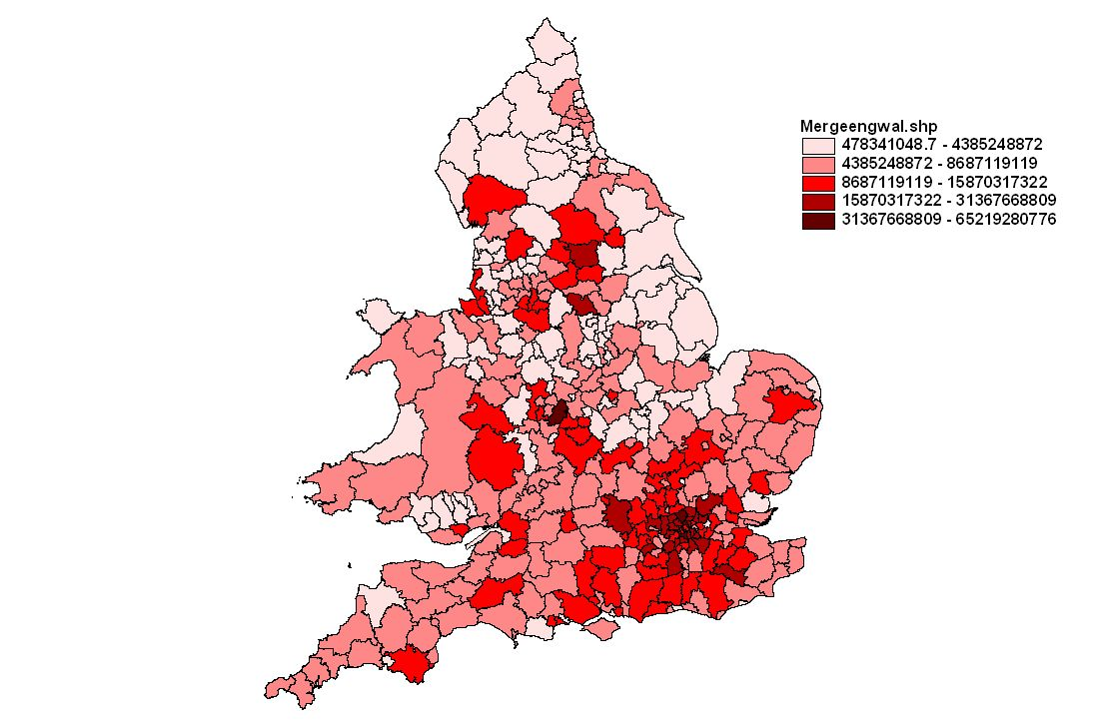
This purports to show the average cost of land per house sold, in each local authority of England and Wales in 4Q 2002. It is based on Land Registry figures, adjusted for regional variations in construction costs and for the proportions of different types of home in each area (i.e. flats, semis, detached, terraced). The darker the shading, the more valuable the land.
This was the final slide in my presentation to the Oxford delegates on 16 September, with the caption: “Best Value Map for 2004!” The full presentation can be viewed at …

Strand 3 - Overseas Fact-finding
The response to my questionnaire on value maps this summer, distributed by FIG (www.fig.net) to several hundred national surveying representatives involved in land information and valuation, was disappointing. In 2001/2 a pilot survey elicited 18 responses. This time, I only received seven replies, which may show that people are overwhelmed with junk emails. I intend to follow up selected contacts by telephone in coming weeks.
Even from the small response to my international enquiries so far, it is clear that a number of countries use value maps and more plan to do so. I had already chosen a more in-depth and focused approach to this strand of the work, by identifying from the pilot survey just four countries as ‘comparators’: Lithuania, Denmark, USA and Australia.
Thanks again to Lincoln Institute, I was able to spend a week in October with Lithuanian, Latvian and American property tax experts in Vilnius, where a workshop for Latvian officials was organised by Lincoln and hosted by the Lithuanian State Enterprise Centre of Registers (SERC) www.kada.lt . A section on this visit is included in a paper that should be published next year by Richmond Law & Tax in their Critical Issues in Environmental Taxation series: (final draft at http://www.landvaluescape.org/archives/GETC5prism.doc
My conclusions in that paper, for an international readership, are summarised as follows:
- The course by which value maps arrive in a country will vary greatly according to its culture, history, economy and system of government.
- The Delphi method of researching this and similar subjects relating to environmental taxation appears suitable for any country or jurisdiction where a common policy or plan of action is under consideration.
- The political and institutional aspects of value mapping are far more difficult and important than the technical aspects.
- In Europe, there is a strong probability that a combination of external global and regional factors will give some initiatives by EU member states a sufficient push – even without a tax modernization imperative – for a nation-wide value mapping programme to evolve on the back of e-government and e-business in the next five to ten years.
- The concept of a ‘State Enterprise Centre for Registers’ deserves to be looked at by any country considering the development of a modern property tax system and/or value mapping. It allows for the integration of key spatial datasets whilst keeping separate, if required, the responsibility for the core functions that primarily justify each one. Site values used in value maps, a product of aggregated and mass-produced tax assessments based on market rents and prices, can be considered as a Register, like land ownership and parcel definitions.
- Transitional economies in Europe that are creating their property markets and geo-spatial data infrastructures from scratch are very likely to lead the way with value mapping for other ‘old Europe’ member states and will be supported by North American and Australasian examples of the art.
- The most efficient and effective way to maximize the use of value maps for the benefit of society, citizens, commerce and governments is to involve the private sector in the necessary investment and exploitation, while retaining responsibility for custodianship within a public body or bodies. Issues of pricing, licensing, privacy and data-sharing are non-trivial but should not be allowed to stand in the way of developing what seems to be an extremely beneficial tool for land policy, property markets and sustainability.
I am currently awaiting a report on recent developments in Denmark, where a decision was taken this summer to incorporate GIS in property tax administration. In 2002 the administration of Denmark’s property taxes, including LVT, was taken away from the municipalities and given to the national government.
Postscript
The Irish Chambers of Commerce have signed up to campaign for LVT as a major source of local authority funding. This ties in with what has happened in parts of the US: entrepreneurs have realised that their interests are distinct from ‘rentiers’ and that a tax on passive land ownership allows taxes on enterprise to be alleviated. See http://www.chambersireland.ie/index.asp?docID=666 But Ireland, thanks to its common history with the rest of the British Isles, is many years away from having the necessary GI infrastructure for a modern property tax. Come back Napoleon!

(see http://www.landvaluescape.org/archives/000012.html)

